Report HW 4 ECE-111
Name: Jasper Huang
PID: A17796149

Homework 4a (LFSR)
- SystemVerilog design code
  - lfsr (student added part)
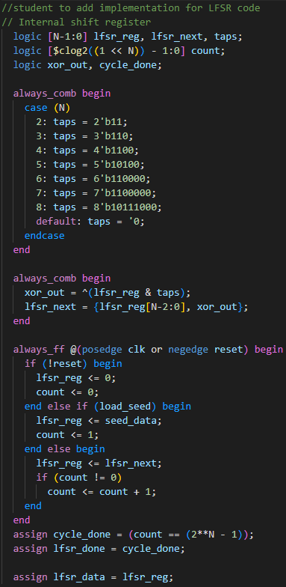
- Synthesis Resource usage and schematic generated from RTL netlist viewer
  - Resource Usage
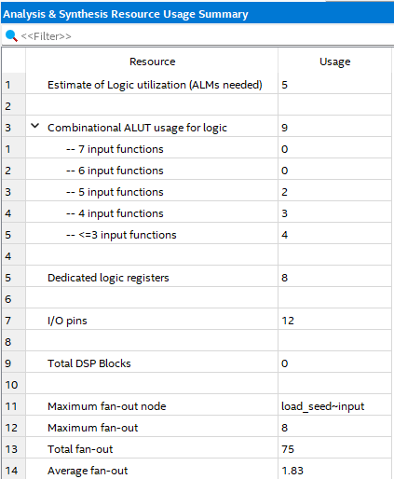
  - RTL netlist viewer
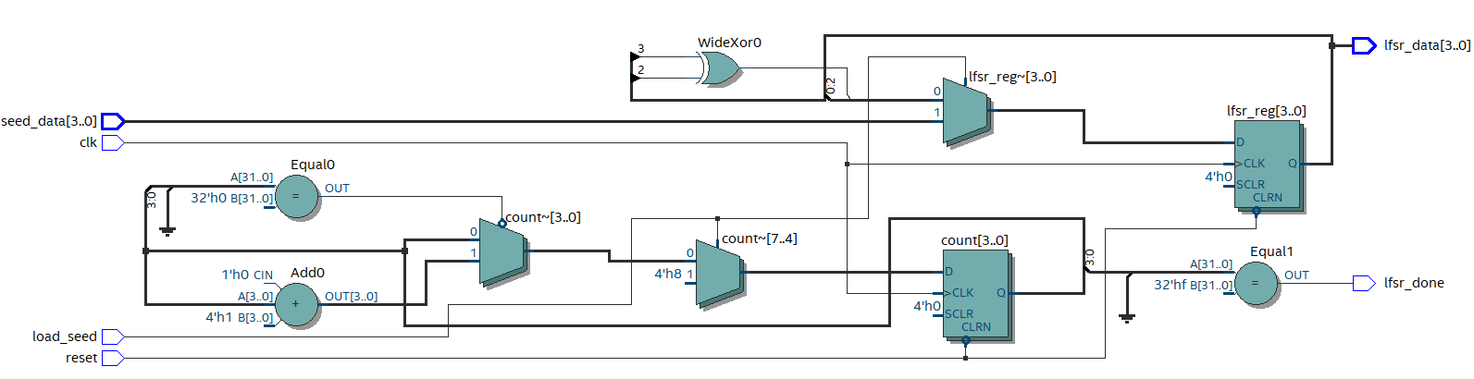
- Simulation snapshot and explain simulation result
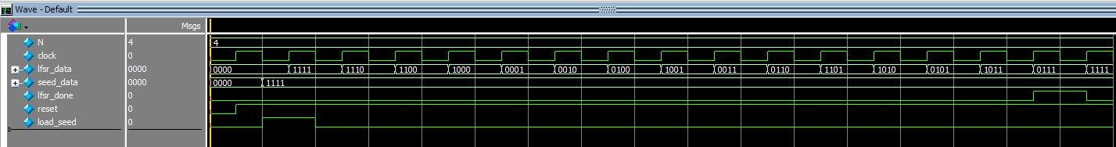
This simulation result shows a full 15 cycles for an N = 4 where the random pattern follows the feedback polynomial of x^4 + x^3 + 1 with max length of 15, which matches the cycle in the above case that goes through 15 different lfsr data.
- Post-Mapping schematic
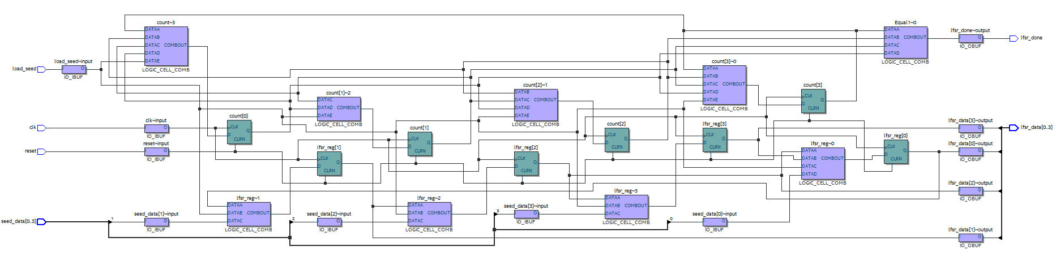

Homework 4b (Barrel Shifter)
- SystemVerilog code snapshot
  - barrel_shifter
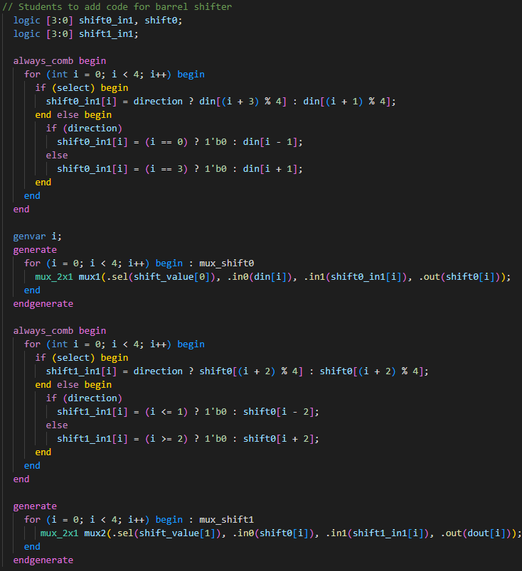

- Synthesis Resource usage and schematic generated from RTL netlist viewer
  - Synthesis Resource usage
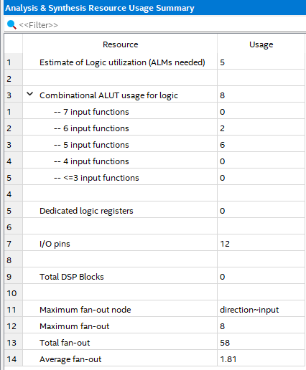
  - RTL netlist viewer
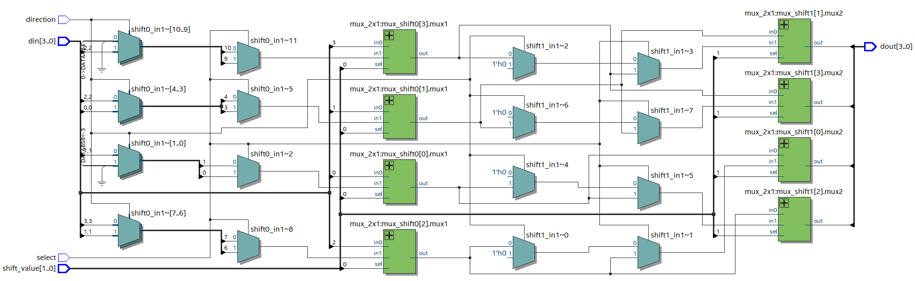

- Simulation snapshot and explain simulation result
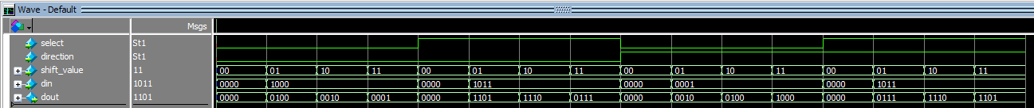
The simulation wave graph shows that under select 0 or 1, for direction 0 or 1, each shift value (00,01,10,11) each din correctly output the dout with the select 0 performs shift, 1 performs rotate, while the direction 0 is to right and 1 is to left, and shift_value is how many bit positions to move. The simulated waveform shows exactly the expected output for each input combinations.

- Post-Mapping schematic
